ELAN Input Device
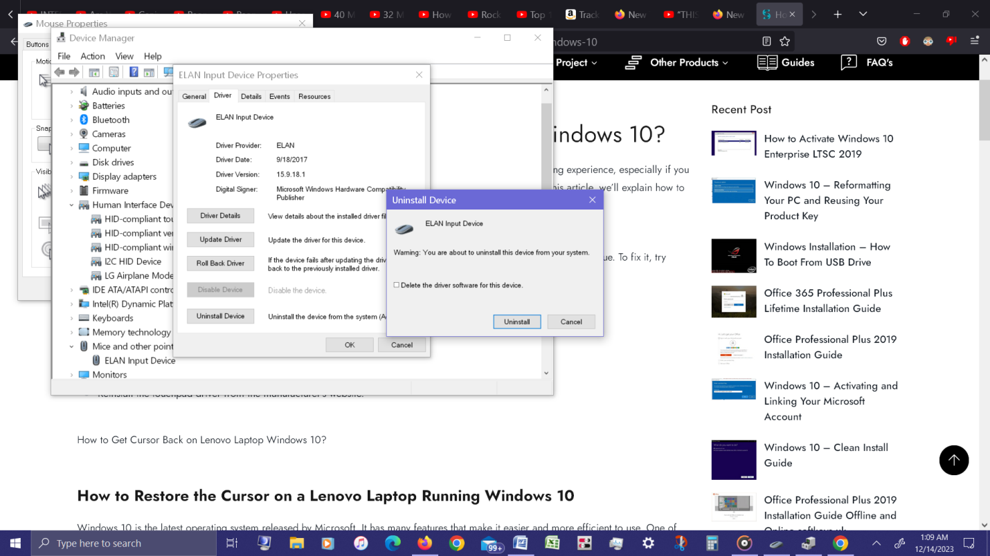

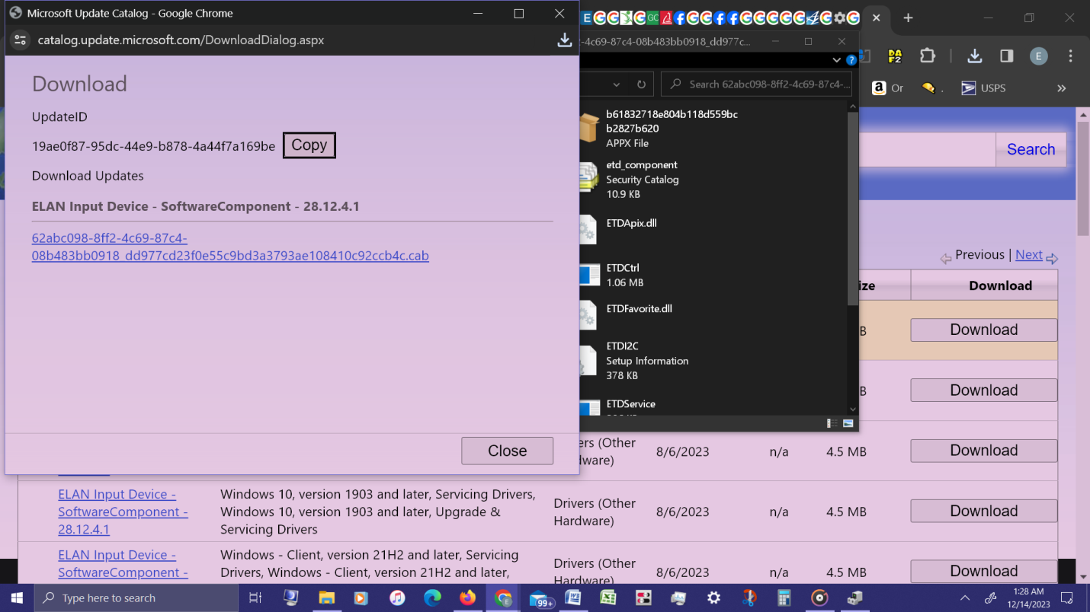
I was wiping my laptop (it's a touchpad) and then all of a sudden it started acting funny. Usually it touches some tabs, close tabs, moves the page up and down and doesn't do much. IDK what happened this time.

1. First, it updated Chrome on it's own, which I don't want. How do I revert back to the previous version.
2. Then, it kept opening up MS Edge. Twice. I had already finished wiping my keyboard, which took 2s, and I didn't touch the laptop. It just opened MS Edge on it's own. Then opened back up when I closed it. Why would it do that on it's own?

*3. Third, it messed up my cursor pointer. When it first happened, it was acting funny, moving slowly, not moving accurately. Then the cursor would disappear altogether. Restarting the laptop didn't help.

Then I read online to uninstall the ELAN Input Device From Device Manager. Then restarted computer. THe cursor came back, but is gone again. And the ELAN Input Device is no longer in the Device Manager&gt;Mice and other pointing devices. I thought it would pop back up but it didn't (when you uninstall the touchpad driver and reboot, it comes back)

&gt;&gt;&gt;I have an LG GRAM 14Z970. Windows 10.
&gt;&gt;&gt;Can someone point me to the direct link to download the ELAN Input Device Driver? Idk which one it is to download

Is this the page to download? And which one?
https://www.catalog.update.microsoft.com/Search.aspx?q=Elan+Input

Also, how do I install it? It saves as a Cabinet File?? How do I extract/install the cab file? I don’t see which one is the .cab file?

